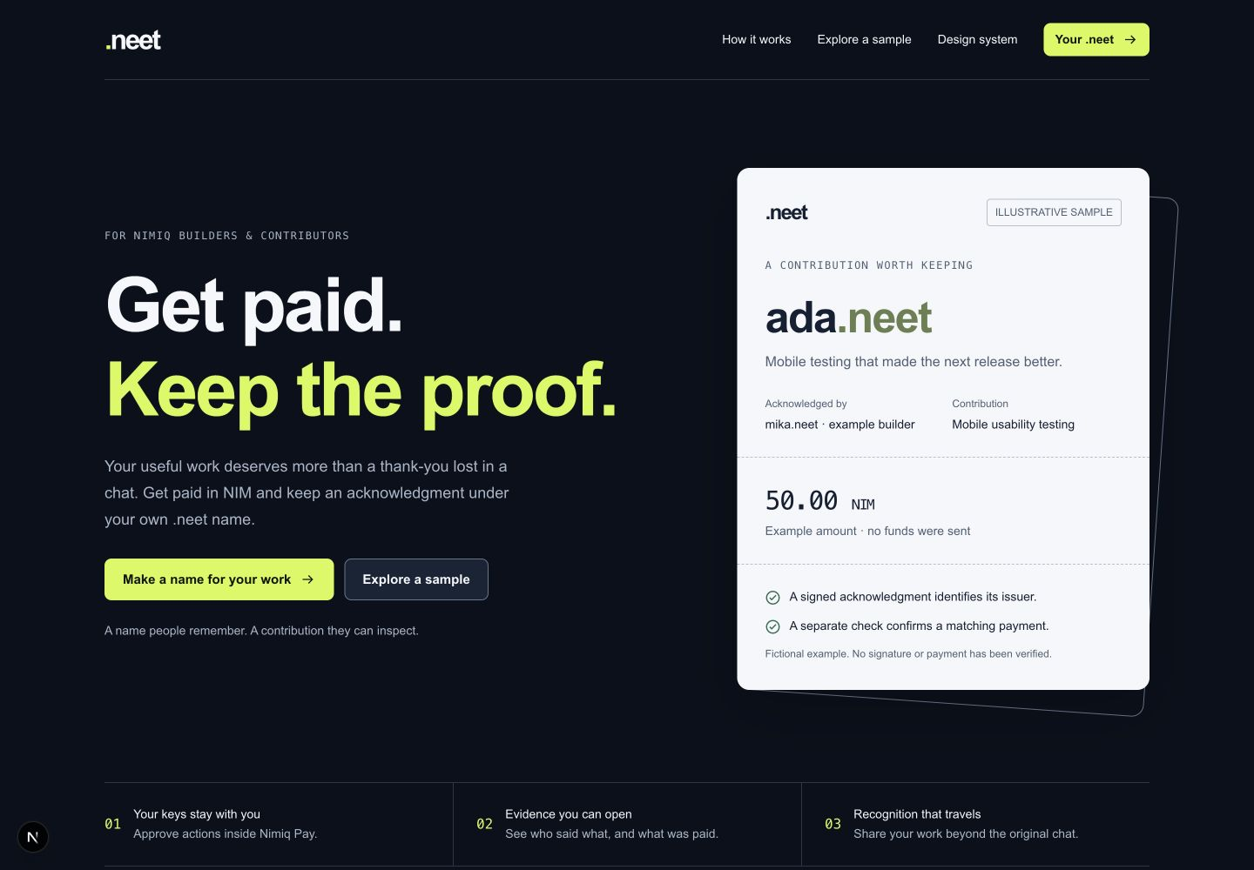

Created the documentation, reusable design system, initial MVP website/backend, and both agent handoffs.
- [Download the complete package( /Codex/2026-09-10/im-currently-ideating-for-the-nimiq/outputs/Dotneet-handoff.zip)
- [Start here: document index and setup]( Codex/2026-09-10/im-currently-ideating-for-the-nimiq/outputs/dotneet/README.md)
- [Design system]( /Codex/2026-09-10/im-currently-ideating-for-the-nimiq/outputs/dotneet/docs/10-design-system.md)
- [Claude continuation prompt]( /Codex/2026-09-10/im-currently-ideating-for-the-nimiq/outputs/dotneet/docs/CLAUDE-CONTINUATION-PROMPT.md)
- [OpenCode starting prompt]( /Codex/2026-09-10/im-currently-ideating-for-the-nimiq/outputs/dotneet/docs/OPENCODE-START-PROMPT.md)
The package includes 41 shared design tokens, ten editable visual templates, and seven screenshots. To continue with Claude, provide the ZIP and its continuation prompt.
Validation: 41 unit tests, 13 PostgreSQL lifecycle scenarios, lint, and the production build passed. Nimiq Pay device testing and real-network payment verification remain required. Nothing was publicly deployed.

